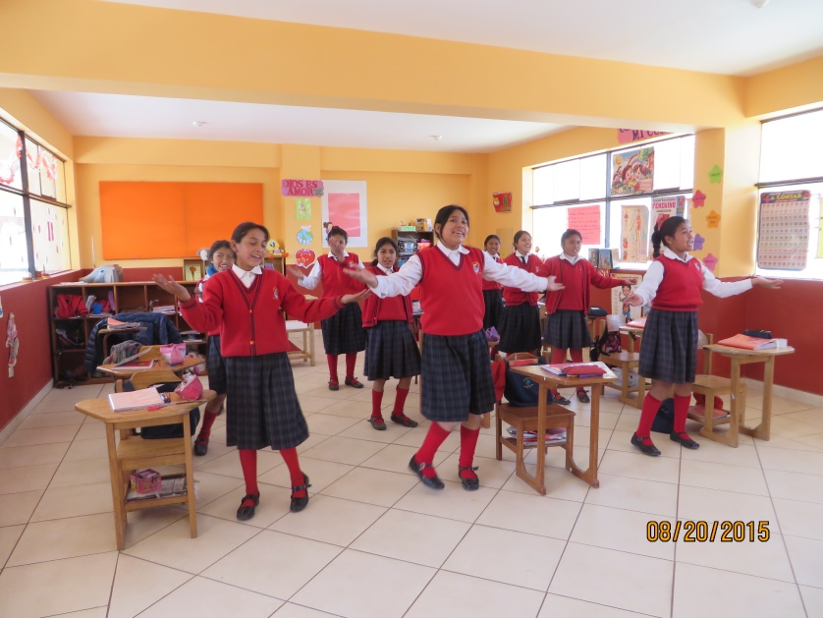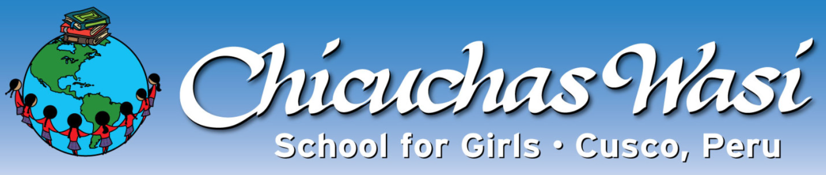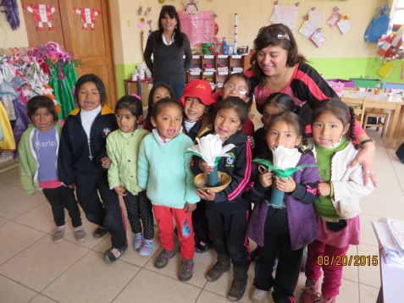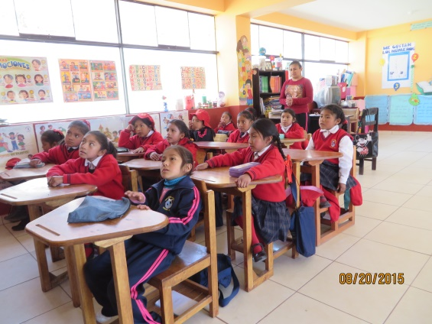

***CW’s 3rd Annual Christmas Peruvian Shopping event***

Open House, Saturday, October 19th from 2pm to 6pm

793 Bowen Court, Sonoma, CA 95476

RSVP to Rae (707) 695-0504 or raelewis@sonic.net

All proceeds to educate Chicuchas Wasi Girls in Cusco, Peru.

Items for sale: Handbags, Alfajores (Peruvian cookies), Earrings, Andean table cloths, placemats, water bottle carriers, chullos (Peruvian hats), purses, T-shirts & more.

CA CW board will be present if you would like to learn more about the program.

